Setting up PGSuper/PGSplice for Regression Testing
Before you can run the regression tests, PGSuper and PGSplice need to be configured with the regression test libraries. This is a one-time setup step. This setup uses the PGSuperRegTestLibrary.lbr file which we don’t change. This file is intentionally filled with dummy data that won’t get used. The tests will then use the library entries within each individual test file making the test case input constant.
One-time set up
- Start BridgeLink
- Select File > Configure BridgeLink…
- On the Configure PGSuper step, press the Manage button and create the “Regression” configuration as shown here.
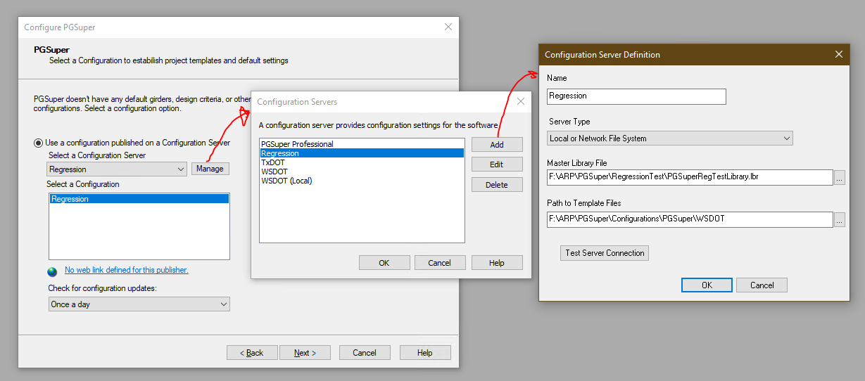
The settings are:
Server Type: Local or Network File System
Master Library File: <Drive>:\ARP\PGSuper\RegressionTest\PGSuperRegTestLibrary.lbr
Path to Template Files: <Drive>:\ARP\PGSuper\Configurations\PGSuper\WSDOT
- Do the same thing with PGSplice
The settings are:
Server Type: Local or Network File System
Master Library File: <Drive>:\ARP\PGSuper\RegressionTest\PGSuperRegTestLibrary.lbr
Path to Template Files: <Drive>:\ARP\PGSuper\Configurations\PGSplice\WSDOT
- Do the same with TOGA, except the configuration name is “TxDOTRegressionTest”
The settings are: Local or Network File System
Master Library File: <Drive>:\ARP\PGSuper\RegressionTest\TxDOTRegressionTest.lbr
Path to Template Files: <Drive>:\ARP\PGSuper\TxDOTAgent\TogaTemplates
- Complete the Configuration Wizard

Running the Regression Tests
Each time before running the regression tests make sure you have a Release build, and the release build is registered (use the Register Release macro on the Tools menu or the toolbar button).
The tests must be run separately for PGSuper and PGSplice. They cannot be run at the same time.
To run the PGSuper tests:
- Start a Windows Powershell or Command Prompt
- Change directory to <Drive:>\ARP\PGSuper\RegressionTest
- Run the following command:
> .\RunRegression_Release.bat /M
The /M option runs multiple files at a time. If the /M option is omitted, the tests are run one at a time, which takes a lot longer to complete.
The regression tests will run for several hours. For this reason, it is best to run the tests on a secondary computer or overnight.
The process is similar for PGSplice, except run .\RunRegression_PGSplice.bat /M. Don’t run this script until after you have resolved the PGSuper test results. Running this script (and the script for PGSuper) clears all the previous “Current” test results.

Getting around the PGSuper/PGSplice one-at-a-time limitation
There is a manual workaround so you can run both the PGSuper and PGSplice regression tests at the same time.
- Run the following command in the regression test folder:
> RunRegression_PGSplice.bat /N > PGSplice.bat
- Open PGSplice.bat in notepad, or similar, and remove the first few lines and the last few lines. The only thing you want in this file is the following line to configure PGSplice for regression testing, followed by lines that start with either executing BridgeLink.exe or cmd.exe
F:\ARP\BridgeLink\RegFreeCOM\X64\RELEASE\BridgeLink.exe /App=PGSPLICE /Configuration="Regression":"Regression"
cmd.exe /C START "XYZ" F:\ARP\BridgeLink\RegFreeCOM\X64\RELEASE\BridgeLink.exe /TestR F:\ARP\PGSuper\RegressionTest\Current\PGSplice\Duckabush_1.spl
The /N option runs through all the regression test files but doesn’t run the tests. This is an easy way to capture the test commands into a batch file.
The above is a one-time set up step (though it needs to be repeated if PGSplice test files are added or removed).
Once you have the PGSplice.bat file, start the PGSuper regression tests as described above. Once they are running, open a second command prompt window, change to the RegressionTest folder, and run the PGSplice.bat file.
The critical thing to know is that PGSuper and PGSplice update their configuration to the “Regression” configuration before the tests run. Errors occur if both programs are updating their configurations at the same time. Starting the PGSuper regression test first updates its configuration and deletes all the older “Current” results files. Once PGSuper is running a test file, start the PGSplice.bat.

Resolving Regression Test Results
To evaluate the test results, open the file <Drive:>\ARP\PGSuper\RegressionTest\PGSuperRegressionTests.WinMerge. This file compares *.dbr and *.Test files in the Current and Datum folders.
The files in the Datum folder are the most recent successful test results – this is the datum we measure against.
The Current folder has the output from the current test run.
WinMerge will show which files are different. Double-clicking on a file will open it up and show the specific differences.

